**FPT ACADEMY INTERNATIONAL**



## FPT – APTECH COMPUTER EDUCATION

GRACIOUS GARMENTS

|  |  |  |  |
| --- | --- | --- | --- |
| **Center Name** | | FPT – Aptech – HCM2  Address: 590 Cach Mang Thang Tam, District 3, Ho Chi Minh City | |
| **Instructor** |  | Ms. Le Mong Thuy |  |
| **Class** |  | T1.2104.E0 |  |
| **Group** |  | 3 |  |
| **Group members** | | **Name** | **Student ID** |
|  |  | Lê Vinh Nam | Student1316201 |
|  |  | Đặng Ngọc Minh Triết | Student1313754 |
|  |  | Phạm Phương Lộc  Trịnh Hoàng Đăng Khoa | Student1313744  Student1316194 |
|  |  |  |  |
|  |  |  |  |
| **Duration** | Start date | 14th July 2021 |  |
| End date | 14th August 2021 |  |

**This is to certify that**

**Mr.:**

Lê Vinh Nam

Đặng Ngọc Minh Triết

Phạm Phương Lộc

Trịnh Hoàng Đăng Khoa

**has successfully designed & developed**

eProject: Gracious Garments

**Submitted by:**

Lê Vinh Nam

**Date of issue:**

**Authorized Signature:**



**TABLE OF CONTENTS**

FPT – APTECH COMPUTER EDUCATION 1

ACKNOWLEDGMENT 4

SYNOPSIS 4

PROBLEM DEFINITION 4

CUSTOMER'S REQUIREMENTS SPECIFICATIONS (CRS) 5

Business/Project Objective: 5

Hardware/ Software Requirements: 6

SCOPE OF THE WORK (IN BRIEF) 7

Architecture and design of the system 8

Diagram of the website 9

TASK SHEET REVIEW 1 10

SITE MAP 11

MOCK OF THE WEBSITE 12

**1.** **Homepage** 12

**2.** **Product** 13

**3.** **Compare** 16

**4.** **Contact us** 17

TASK SHEET REVIEW 2 22

WEBSITE DESCRIPTION 23

**1.** **Home Page** 23

**2.** **Product Page** 25

**3.** **Contact** 26

TASK SHEET REVIEW 3 34

# ACKNOWLEDGMENT

On behalf of all the members of group 3, I would like to thank you all for the hard works, supports to make this eProject complete successfully. Especially, Ms. Le Mong Thuy, our teacher, she helped us a lot from the day that we started to study at FPT Aptech. With this eProject, she has guided us with her enthusiasm and rigorous, because of her guiding, we would be able to finish this project. Besides, I want to thank all the team member of group 3, each of the team member has been working continuously in 4 weeks in order to complete this project. The last but not least, we would like to say thank you to our family for always supporting us, creating the best conditions for us to focus on the project, and putting faith in the dreams we pursue.

# SYNOPSIS

We need to create a website that meet all the requirement of our customer, Gracious Garments. Gracious Garments is a fashion store that provide fashion clothes. They have a big collection garments. The main purpose of this website is to reach to the customer, who have interest in fashion and looking for a place that they can live with their passion.

# PROBLEM DEFINITION

The Web site is to be created based on the following requirements:

1) The Home Page should be created making use of Sections with a suitable logo, the header section can be added which will show images clothes.

2) The site must contain the links to navigate through any category for the information.

3) The site should display a menu which will contain the options for brief introduction about the various garment’s available, location of the shop and any other information if required.

4) The information should be categorized according to the brand names of the clothes like if a User wants to see only “Gucci” fashion or any other companies clothes then he/she can click on a Link/button/menu etc and can see only that Brand clothes.

5) When a user selects any particular brand, a list of clothes for that brand will be displayed.

6) The user should also be able to compare the various clothes of different as well as similar brands.

7) There should be a “Contact Us” page which will have the Address of the Company which should be displayed using Geo Location API (eg. Google Maps) and the email address which when clicked will invoke the local mail client from where they can send an email.

# CUSTOMER'S REQUIREMENTS SPECIFICATIONS (CRS)

**Client: Gracious Garments**

### Business/Project Objective:

GRACIOUS GARMENTS is selling various types of GARMENTS for both MEN and WOMEN. The company determined to deliver style to shoppers worldwide. Our store offers a huge collection of goods at affordable prices, and our payment and shipping options are simply unmatched.

We are supposed to create a website for them with the below mentioned requirement specifications.

The website is to be developed for the Windows Platform using HTML5, JavaScript, Bootstrap, jQuery and Geolocation. The site should work well in all leading browsers including Chrome, IE, Firefox etc.

**Input to the system:**

* + - * Filter products based on gender, brands.
      * Searching products based on name.
      * Compare products of difference brands as well as similar
      * Personal information for shop to contact.

**Output from the system:**

* A menu that will categorize all the products.
* Display the list of available brands category wise.
* Brands can be of any gender.
* Perform the search based on a particular: gender, brands.
* Display the details (price, brand’s name, origin, sizes, etc.) of products.
* Site should be able to provide brief introduction/history about the shop under About Us.
* The location of the shop under Contact-Us page.
* Besides the above requirements, the site should have look and feel as per the industry standards.

**Expected delivery date:** 09-August-2021.

**List of deliverables:**

* + - * Document Word.
      * User Guide.
      * Source code.

### Hardware/ Software Requirements:

* **For developer**

**Hardware**

* + Intel Pentium 4 processor or higher
  + 1 Gigabytes of RAM or higher

**Software**

* + Windows 7 OS or higher
  + Adobe Dreamweaver
  + Web browsers such as IE, Chrome or Firefox are supporting HTML5, CSS3 and Javascript.
* **For web users**

**Hardware**

* + Intel Pentium 4 processor or higher
  + 512 Megabytes of RAM or higher

**Software**

* + Windows XP OS or higher
  + Web browsers such as IE, Chrome or Firefox are supporting HTML5, CSS3 and Javascript.

# SCOPE OF THE WORK (IN BRIEF)

After a long and detailed discussion, our group has decided to create a website contain the following webpages:

1. ***Homepage***: Display information about collection, an introduction about us Gracious Garments, team members who created the website.
2. ***Product***: Display all available brands based on category (gender, brands,…).
3. ***Compare***: Displays all the products for user want to compare.
4. ***Contact***: Display the address of the company and e-mail to contact, allow customers to request any information they want to know about *Gracious Garments*.

# Architecture and design of the system

Webpage request



Requested Page

**RENDERING**

**ENGINE**

**CSS CODE**

**HTML CODE**

**WEB SERVER**

**WEB BROWSER**

**CLIENT**

**SERVER**

# Diagram of the website

|  |
| --- |
| **C:\Users\Admin\Downloads\Untitled Diagram.png** |



# TASK SHEET REVIEW 1

|  |  |  |  |  |  |  |  |
| --- | --- | --- | --- | --- | --- | --- | --- |
| **Project Ref. No.:**  **eP/Advertisement Portal Management**  **System/01** | | **Project Title:** | **Activity Plan Prepared By:** | **Date of Preparation of Activity Plan:** | | | |
| **Sr.**  **No.** | **Task** | **Actual**  **Start Date** | **Actual Days** | **Team**  **Mate Names** | **Status** |
| 1 | Problem Statement | Gracious  Graments | Nam | 14-July-21 | 1 | Triet | Completed |
| 2 | Analysis of Gracious Graments requirements about the website | 14-July-21 | 1 | Loc | Completed |
| 3 | The scope of the work (in brief) | 14-July-21 | 1 | Khoa | Completed |
| 4 | Architecture and design of the system | 14-July-21 | 1 | Khoa | Completed |
| 5 | Diagram of the website | 14-July-21 | 1 | Nam | Completed |
| 6 | Task Sheet | 14-July-21 | 1 | Nam | Completed |

|  |  |
| --- | --- |
| **Date:** | |
| Signature of Instructor:  **Ms. Le Mong Thuy** | Signature of Team Leader:    **Le Vinh Nam** |

# SITE MAP

|  |
| --- |
| C:\Users\Admin\Downloads\Untitled Diagram 2.png |

1. **Homepage**

# MOCK OF THE WEBSITE

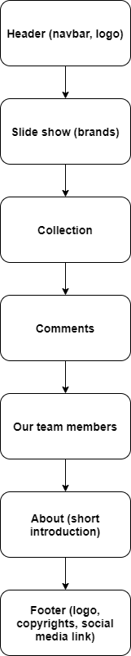

1. **Product**

|  |
| --- |
|  |

### Compare

|  |
| --- |
|  |

### Contact

|  |
| --- |
|  |



# TASK SHEET REVIEW 2

|  |  |  |  |  |  |  |  |
| --- | --- | --- | --- | --- | --- | --- | --- |
| **Project Ref. No.:**  **eP/Advertisement**  **Portal Management System/01** | | **Project Title:** | **Activity Plan Prepared By:** | **Date of Preparation of Activity Plan:** | | | |
| **Sr.**  **No.** | **Task** | **Actual Start Date** | **Actual Days** | **Team Mate Names** | **Status** |
| 1 | Site map | Gracious  Graments | Nam | 18-July-21 | 1 | Lộc | Completed |
| 2 | Mock of the website | 18-July-21 | 2 | Triết | Completed |
| 3 | Task sheet | 18-July-21 | 2 | Khoa | Completed |

|  |  |
| --- | --- |
| **Date:** | |
| Signature of Instructor:  **Ms. Le Mong Thuy** | Signature of Team Leader:  **Le Vinh Nam** |

# WEBSITE DESCRIPTION

1. **Home Page**
2. Description: Include Navigation Bar and some features products

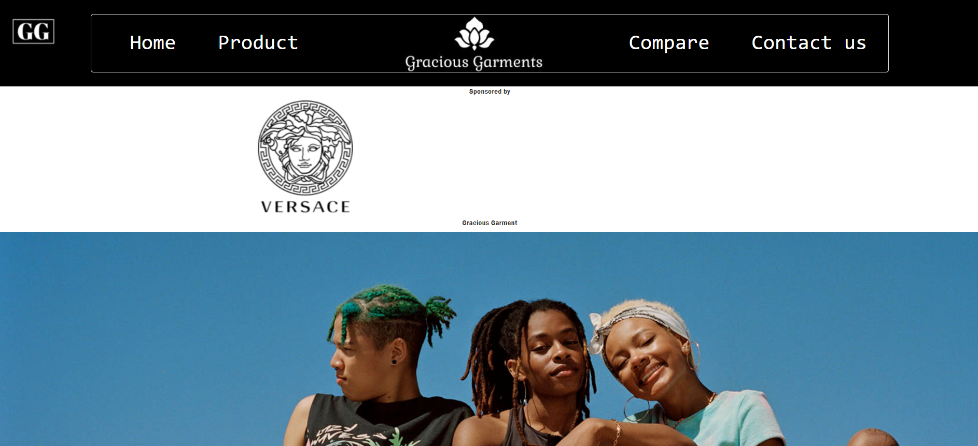

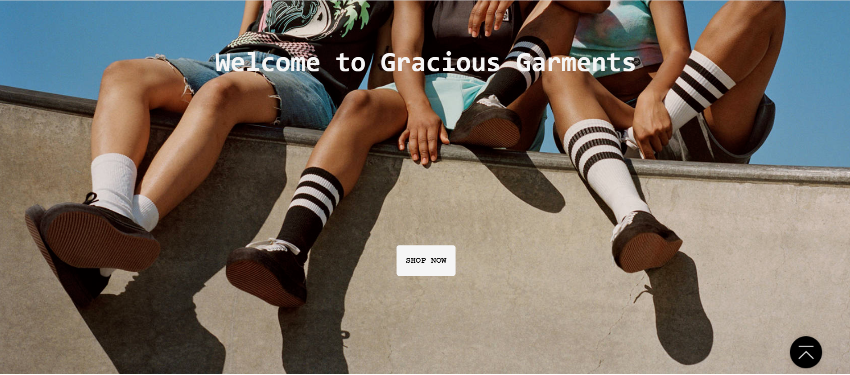

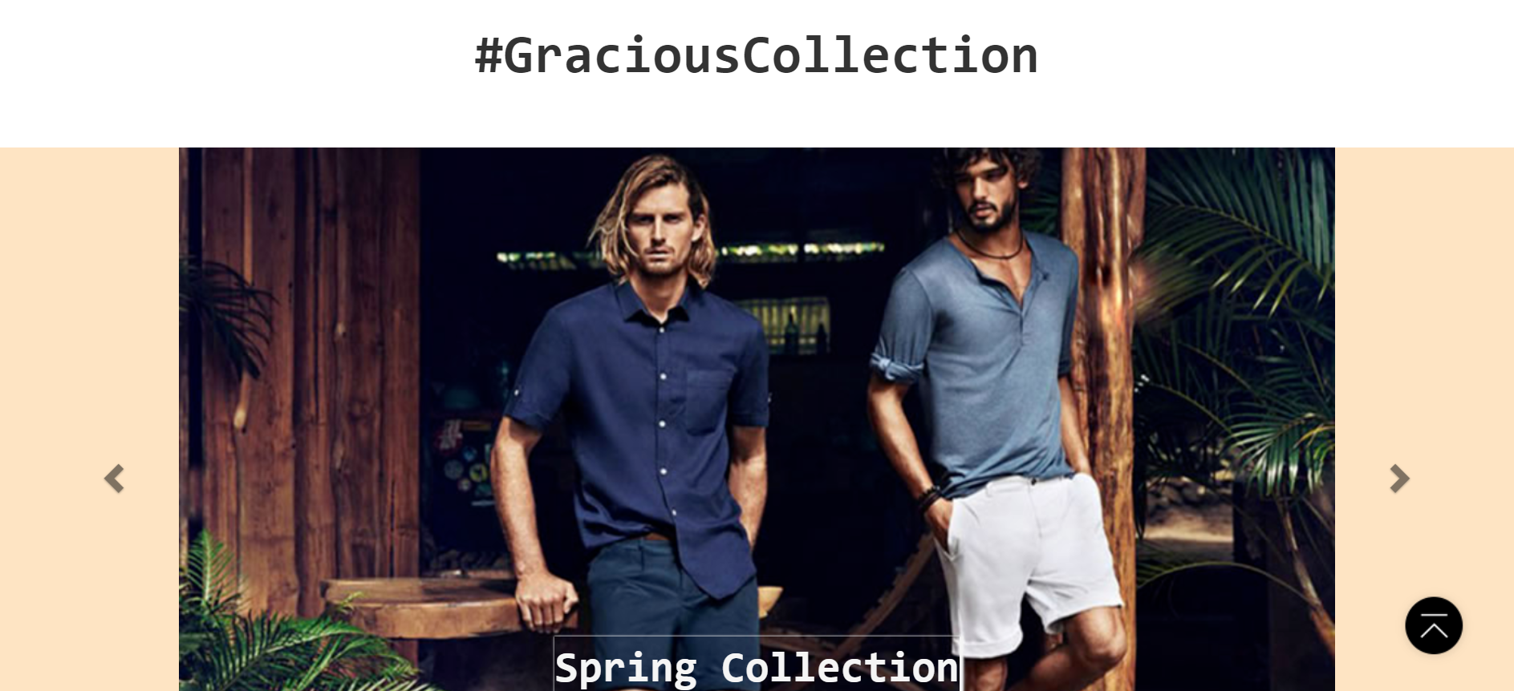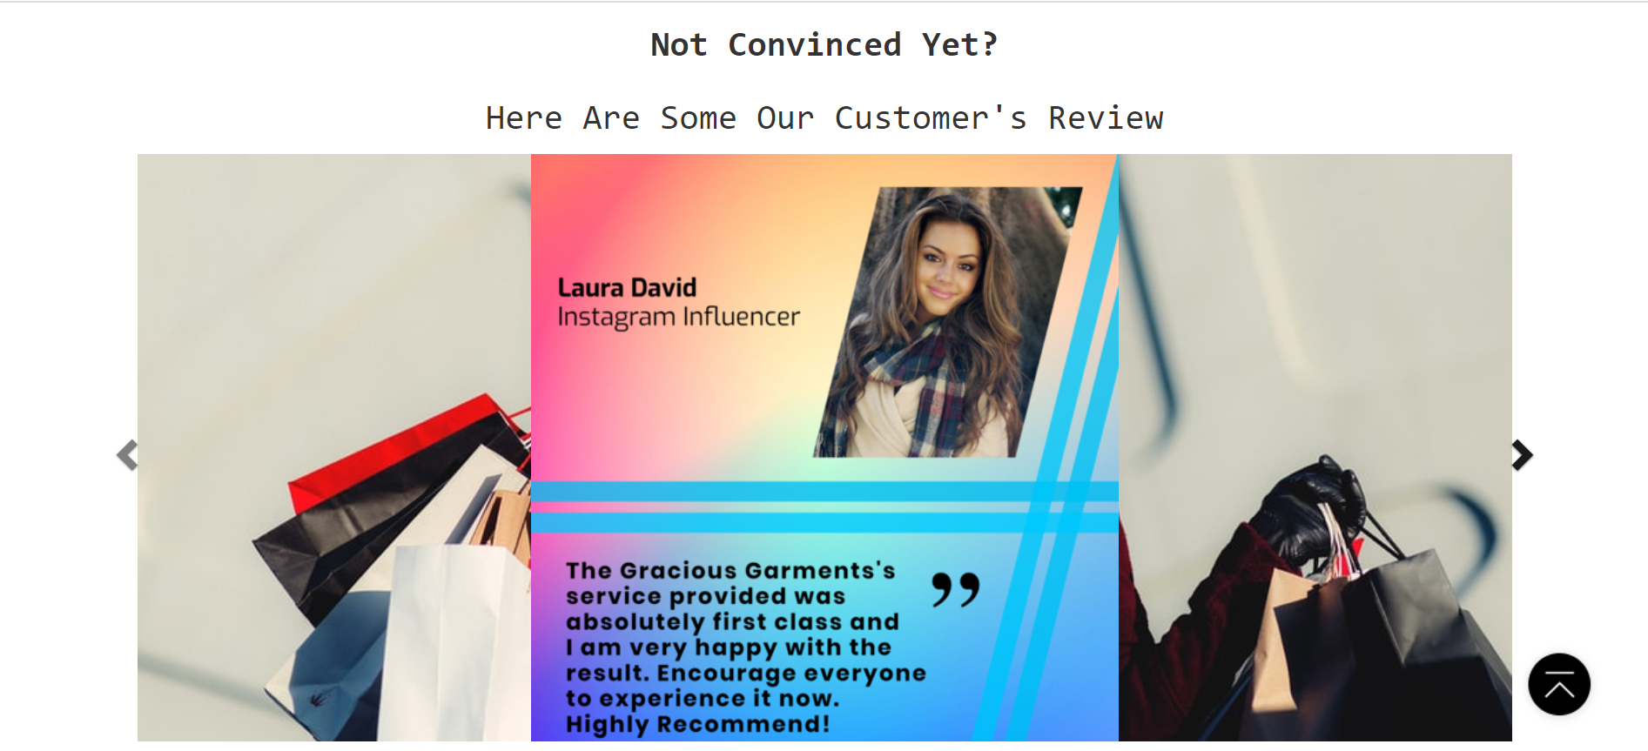



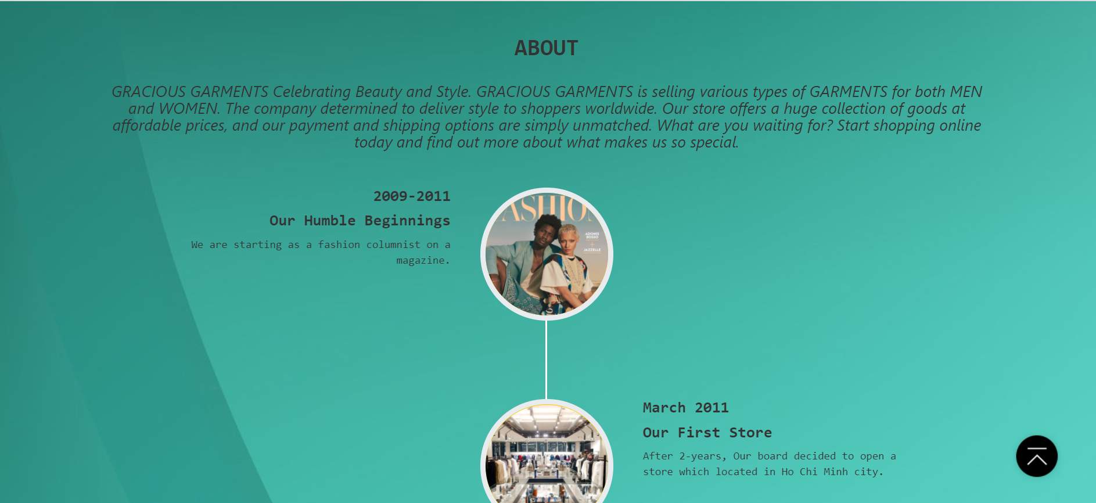

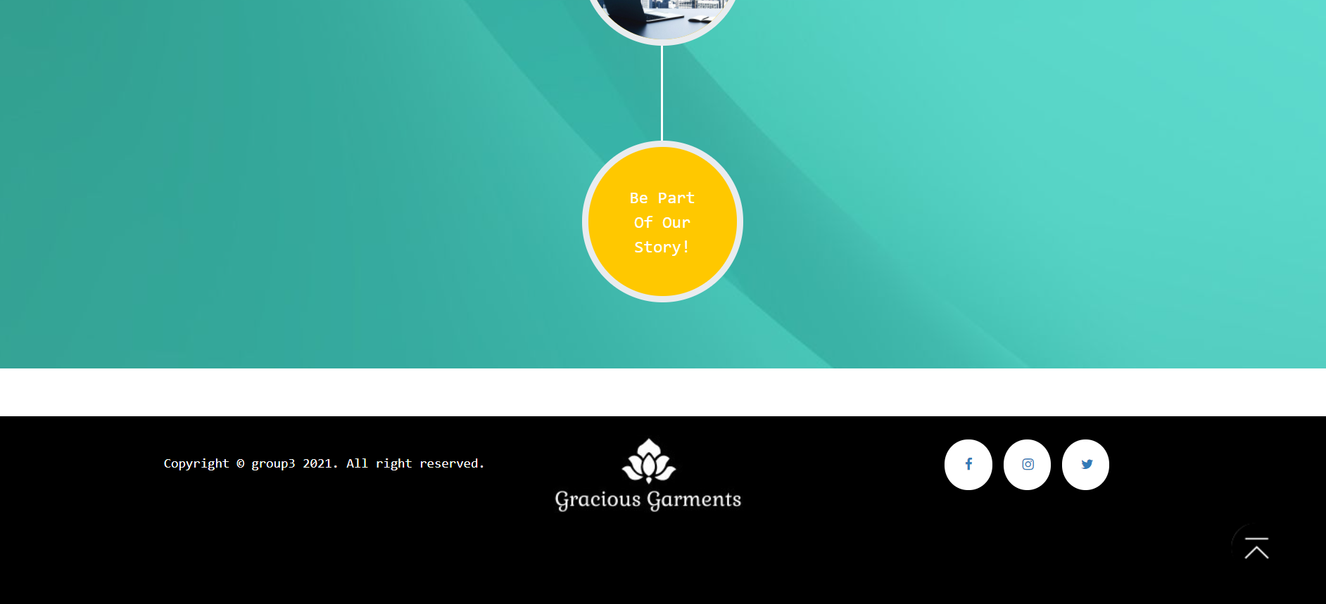

**2.Products Page**

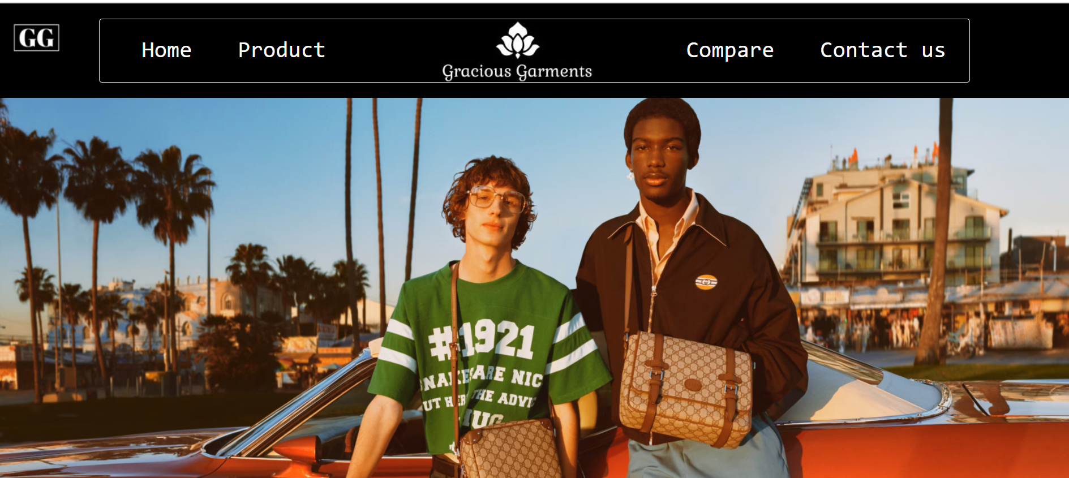

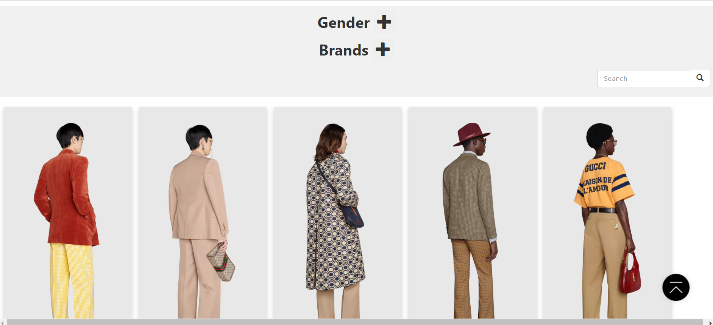

**3.Contacts Page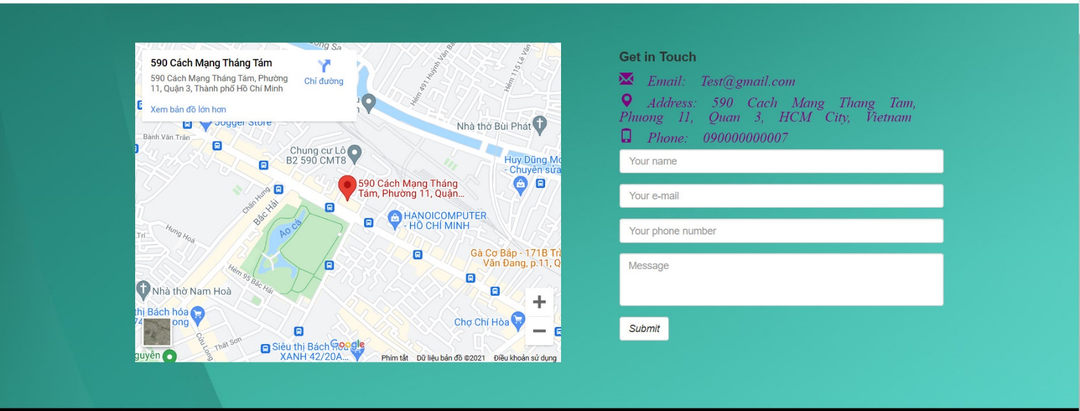4.Comparision Page**

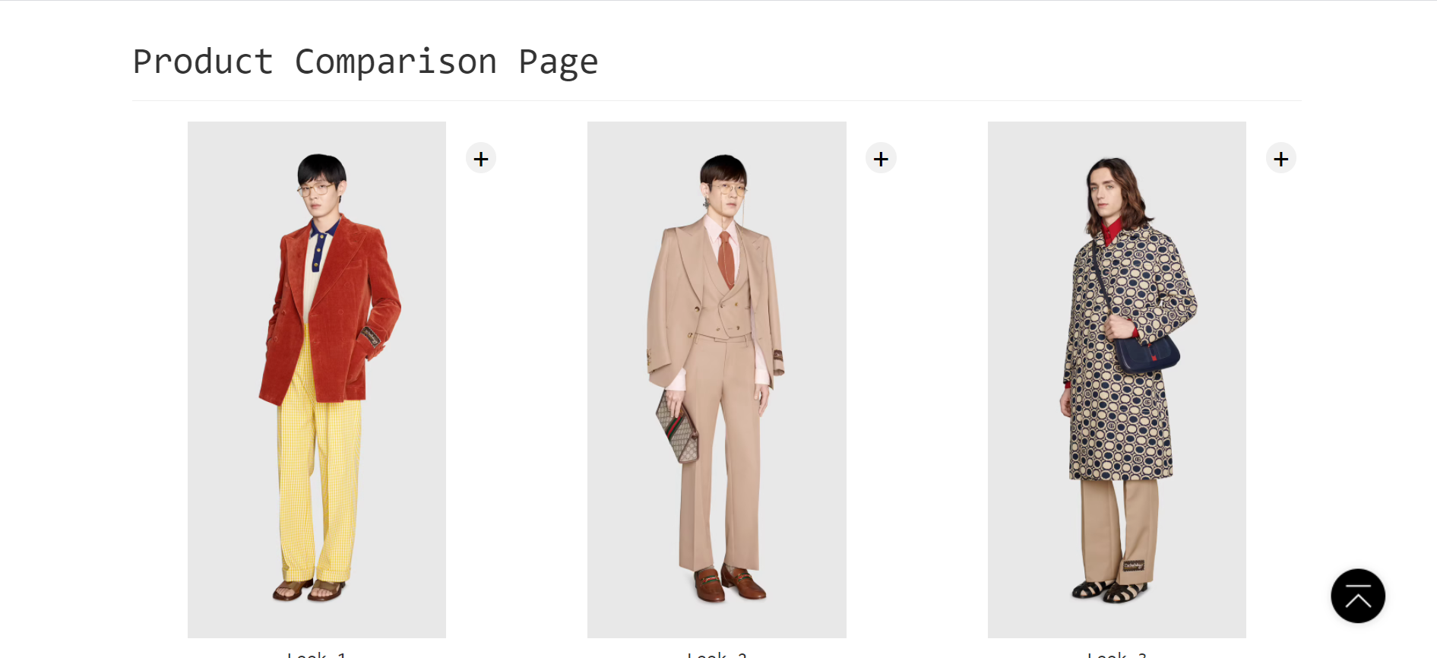

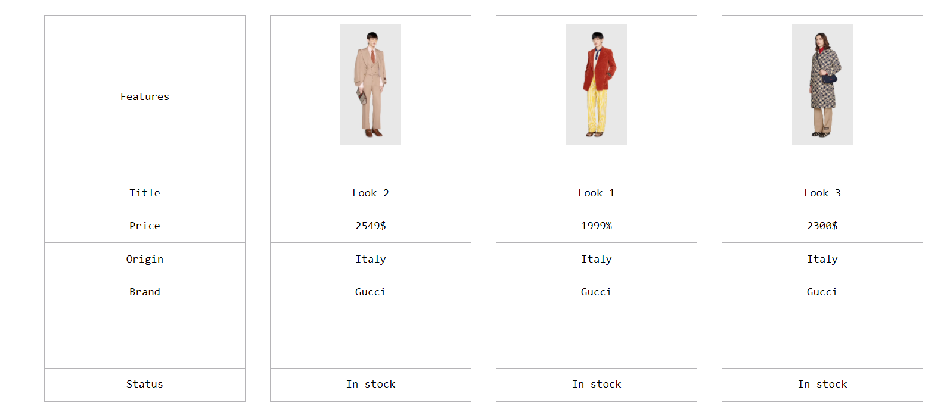

**RESPONSIVE**

The page has responsive feature for small screen device such as smart phone, tablet, etc.

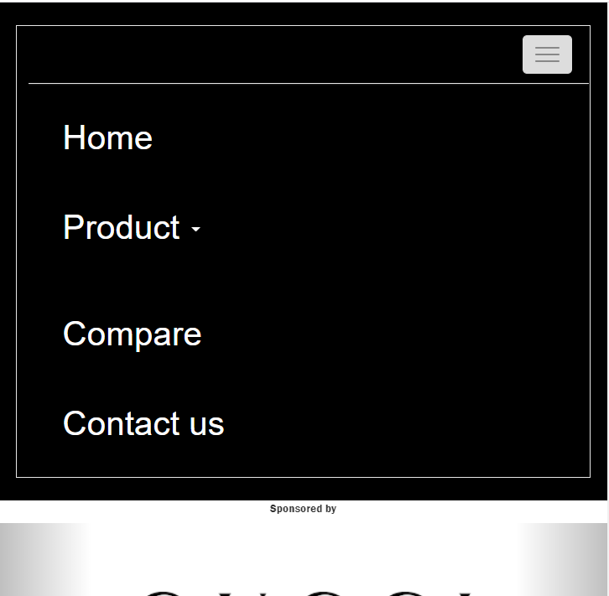

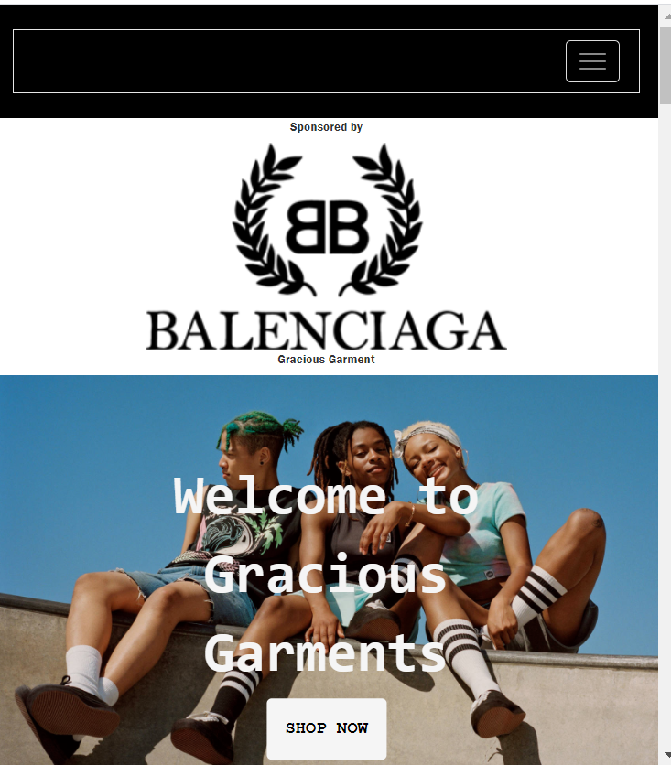

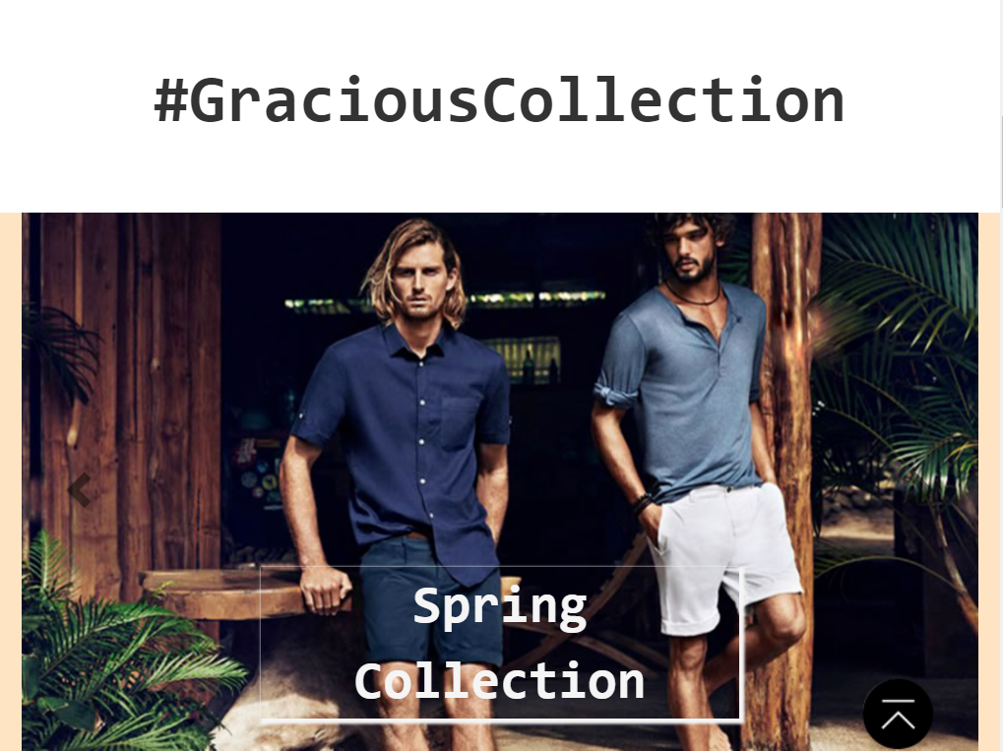

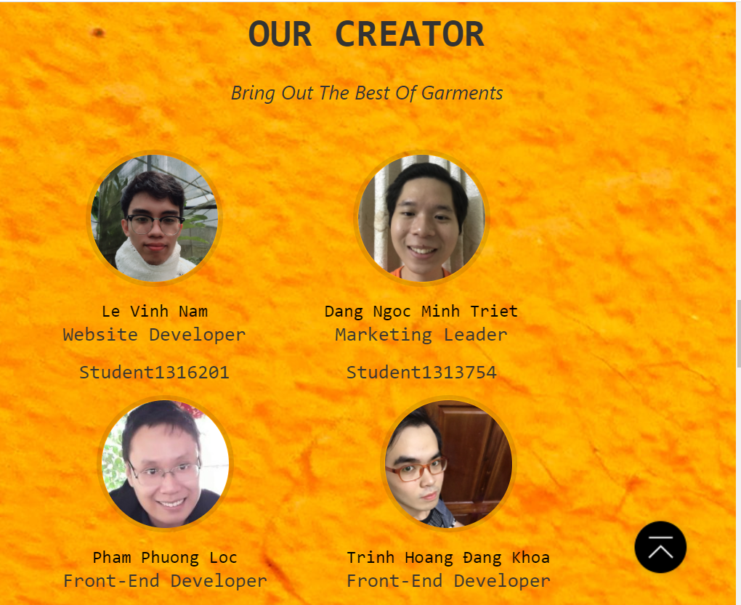

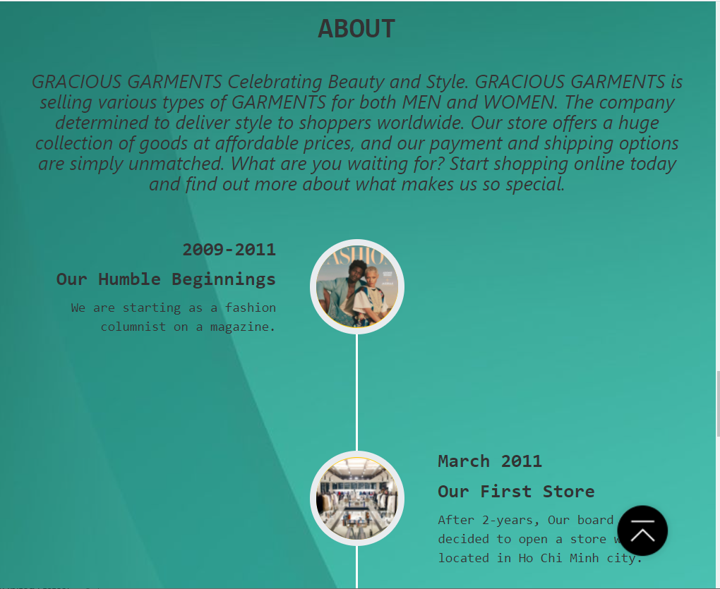

# TASK SHEET REVIEW 3

|  |  |  |  |  |  |  |  |
| --- | --- | --- | --- | --- | --- | --- | --- |
| ***Project Ref. No.:***  ***eP/Advertisement Portal Management System/01*** | | ***Project Title:*** | ***Activity Plan Prepared By:*** | ***Date of Preparation of Activity Plan:*** | | | |
| ***Sr.***  ***No.*** | ***Task*** | ***Actual Start***  ***Date*** | ***Actual Days*** | ***Team Mate***  ***Names*** | ***Status*** |
| *1* | *Home page* | *Gracious*  *Garments* | *Nam* | 23-Jul-21 | *1* | *Khoa* | *Completed* |
| *2* | *Products Page* | 23-Jul-21 | *1* | *Lộc* | *Completed* |
| *3* | *Contact Page* | 23-Jul-21 | *1* | *Triết* | *Completed* |
| *4* | *Comparision Page* | *23-Jul-21* | *1* | Triết | *Completed* |

|  |  |
| --- | --- |
| **Date:** | |
| Signature of Instructor:  **Ms. Le Mong Thuy** | Signature of Team Leader:  **Le Vinh Nam** |